We have a new animal at Inscape………..
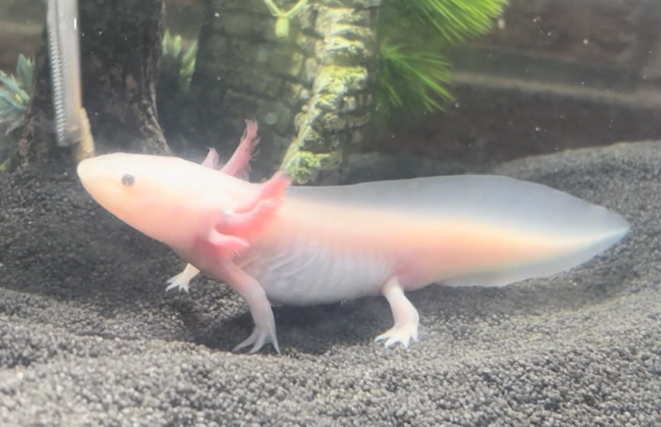

Welcome our new Axolotl !!!
Please vote for the name you wish to call our Axolotl by putting a tick next to the name.
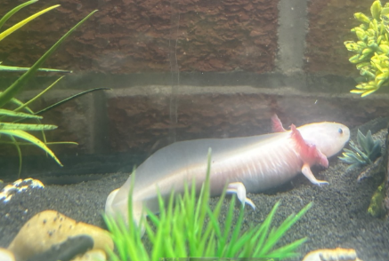
– Please return the slips to Danielle’s AAI room which is next to the science room in the Stevenson building by Friday 1st November
Axol
Axolotl
Axolotl Rose
Axie
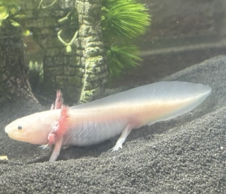
Jelly
Gizmo
Sushi
Other…………………………

